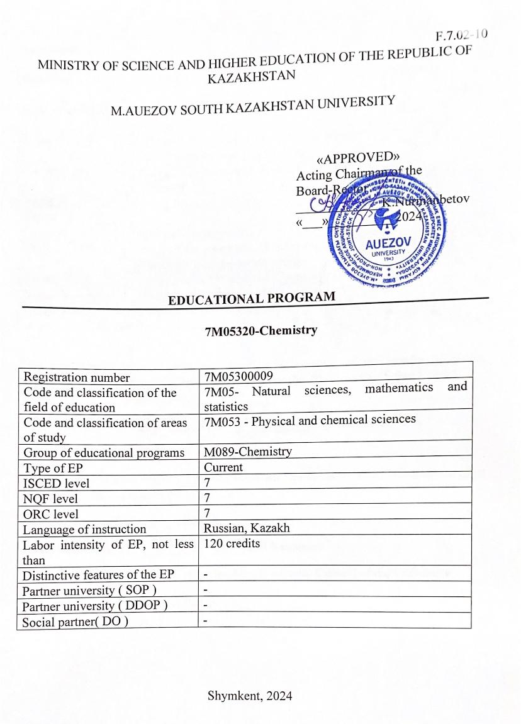

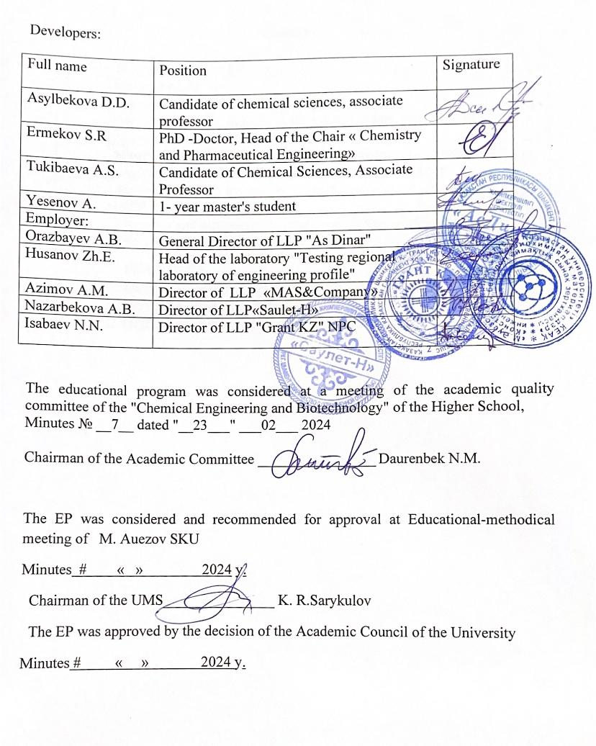

Content

|  |  |  |
| --- | --- | --- |
| 1 | The concept of the EP | 5 |
| 2 | Passport of the EP | 7 |
| 3 | Graduate competencies of the EP | 10 |
| 3.1 | Correlation matrix training in the EP as a whole with the formed competencies | 12 |
| 4 | Matrix of influence of modules and disciplines on the formation results training and information about the labor intensity | 13 |
| 5 | Summary table on the volume of disbursed loans in the context of EP modules | 28 |
| 6 | Strategies and methods of teaching, monitoring and evaluation | 29 |
| 7 | Educational and resource support of the EP | 30 |
|  | Approval sheet | 33 |
|  | Appendix 1. Review from the employer | 34 |
|  | Appendix 2. Expert opinion | 35 |

**1. The concept of the EP**

|  |  |
| --- | --- |
| **The mission of the University** | Generation of new competencies, training of a leader who translates research and entrepreneurial thinking and culture |
| **University Values** | * Openness – open to change, innovation and cooperation. * Creativity – generates ideas, develops them and turns them into values. * Academic freedom - free to choose, develop and act. * Partnership – creates trust and support in a relationship where everyone wins. * Social responsibility – ready to fulfill obligations, make decisions and be responsible for their results. |
| **Graduate Model** | * Deep subject knowledge, their application and continuous expansion in professional activity * Information and digital literacy and mobility in rapidly changing conditions * Research skills, creativity and emotional intelligence * Entrepreneurship, independence and responsibility for their activities and well-being * Global and national citizenship, tolerance to cultures and languages |
| **Uniqueness of EP** | It is based on the training of highly qualified specialists with in-depth theoretical and practical training in various areas of chemical technology. The educational program is aimed at achieving learning outcomes through the organization of the educational process using the principles of the Bologna Process, practice-oriented, student-centered learning, accessibility and inclusiveness. |
| **Academic Integrity and Ethics Policy** | * The University has taken measures to maintain academic integrity and academic freedom, protect against any kind of intolerance and discrimination: * Rules of academic integrity (Minutes of the Academic Council №3 dated 30.10.2018); * Anti-Corruption Standard (Order №373 n/a dated 27.12.2019); * Code of Ethics (Protocol of the Academic Council №8 dated 31.01.2020). |
| **Regulatory framework for the development of EP** | 1. Law of the Republic of Kazakhstan "On Education";  2. Standard rules of activity of educational organizations implementing educational programs of higher and (or) postgraduate education, approved by Order of the Ministry of Education and Science of the Republic of Kazakhstan dated October 30, 2018 No. 595 with amendments and additions dated December 29, 2021 No. 614  3. State obligatory standards of higher and postgraduate education, approved by order of the Ministry of Education and Science of the Republic of Kazakhstan dated July 20.2022 No. 2;  4. Rules for organizing the educational process on credit technology of education, approved by order of the Ministry of Education and Science of the Republic of Kazakhstan dated April 20, 2011 No. 152;  5. Qualification directory of positions of managers, specialists and other employees, approved by order of the Minister of Labor and Social Protection of the Population of the Republic of Kazakhstan dated December 30, 2020 No. 553.  6. Guidelines for the use of ECTS.  7. Guidelines for the development of educational programs for higher and postgraduate education, Appendix 1 to the order of the Director of the Center for the Bologna Process and Academic Mobility No. 45 o / d dated June 30, 2021 |
| **Organization of the educational process** | * Implementation of the principles of the Bologna Process * Student-centered learning * Availability * Inclusivity |
| **Quality assurance of EP** | * Internal quality assurance system * Involvement of stakeholders in the development of the EP and its evaluation * Systematic monitoring * Updating the content (updating) |
| **Requirements for applicants** | They are established according to the Standard Rules for admission to training in educational organizations implementing educational programs of higher and postgraduate education, Order of the Ministry of Education and Science of the Republic of Kazakhstan №600 dated 31.10.2018. |

**2. Passport of the EP**

|  |  |
| --- | --- |
| **Target of EP** | Training of masters who have the skills of logical analysis of solutions to the tasks set, the culture of communication and speech in the conduct of discussions , who have communication skills in a national and international team |
| **Tasks of EP** | **-** formation of socially responsible behavior in society, understanding the importance of professional ethical standards and following these standards;  - providing basic bachelor's training, allowing them to continue their education throughout their lives, to successfully adapt to changing conditions throughout their professional career;  - providing conditions for acquiring a high general intellectual level of development, mastering literate and developed speech, culture of thinking and skills of scientific organization of labor in the field of chemical technology;  - creation of conditions for intellectual, physical, spiritual, aesthetic development to ensure the possibility of their employment in their specialty or continuing education at subsequent levels of education. |
| **Harmonization of EP** | * 7 of the National Qualifications Framework of the Republic of Kazakhstan; * Dublin descriptors ; * 2 cycle of the Qualifications Framework of the European Higher Education Area. (A Framework for Qualification of the European Higher Education Area); * 7 level of the European Qualifications Framework for Lifelong Learning ( The European Qualification Framework for lifelong learning . |
| **Connection of EP with professional sphere** | - Sectoral Qualifications Framework for Education (Approved by Protocol No. 2 of the Meeting of Sectoral Tripartite Commissions on Social Partnership and Regulation of Social and Labor Relations under the Ministry of Education and Science of the Republic of Kazakhstan dated November 23, 2016. Professional standard : university teacher No. 3 dated May 30, 2019 and with Annex 2 to the Sectoral Qualifications Framework "Oil and Gas Processing and Sales", Annex No. 31. No. 266 dated December 27, 2019 "Quality control of oil, oil products". |
| **Name of the degree awarded** | After the successful completion of this EP, the graduate is awarded master of Science in the educational program "7М05320-Chemistry" code and name of the educational program" |
| **Scroll qualifications and positions** | - researcher, teacher at universities in (research institutions, design and design organizations) without presenting requirements for work experience in accordance with the qualification requirements of the Qualification Directory for the positions of managers, specialists and other employees, approved by order of the Minister of Labor and Social Protection of the Population of the Republic of Kazakhstan dated May 21, 2012 No. 201o-m. |
| **Sphere of professional activity** | The sphere of professional activity is government bodies in the field of education, chemical industry; research institutes and central plant laboratories of chemical, environmental, pharmaceutical, metallurgical, petrochemical, gas and coal profiles; institutions of the control and analytical service; centers of standardization and certification; bodies of natural resources and environmental protection. |
| **Objects of professional activity** | The objects of professional activity are production laboratories of analytical, environmental, customs, sanitary and epidemiological, certification services; research organizations ( institutes, laboratories) of the chemical, ecological, metallurgical pharmaceutical profile, secondary schools, colleges, lyceums, gymnasiums, departments of education |
| **Subjects of professional activity** | - research and engineering companies; - research and engineering companies,  - research laboratories;  - higher and secondary educational institutions;  - chemical and petrochemical plants and enterprises |
| **Types of professional activity** | * Organizational and technological; * Research; * Production and management; * Educational (pedagogical). |
| **Learning Outcomes** | **LO1** - Conducts scientific research using modern experimental technologies aimed at self-development and the acquisition of new knowledge  **LO2** - Possesses fundamental knowledge of chemistry, worldview views on the development of modern inorganic and organic chemistry, projecting knowledge and skills into the synthesis of new products, chemical production through scientific research  **LO3** - Applies in the industrial field knowledge about the laws and modern theories of physical chemistry and its main sections: thermodynamics and kinetics, disperse systems and surface phenomena, solving actual problems and analyzing the results of scientific experiments  **LO4** – Solve hardware and production problems in chemical technology, applying theoretical and applied knowledge of the subject area of chemistry  **LO5** - Integrates fundamental, applied knowledge of the chemistry of complex compounds, crystal chemistry of inorganic compounds and the prospects for their application  **LO6 -** Applies and develops new modern methods of analysis and processing of data obtained in the course of research based on scientific, methodological, mathematical modeling and statistical approaches  **LO7 -** Conduct analytical work with the involvement of information resources, using knowledge of a foreign language ; summarize the results of the study in scientific articles, reports and dissertations.  **LO8 -** Analyze worldview and methodological problems, incl . interdisciplinary nature, based on the provisions of the philosophy of science; apply knowledge of research methodology in professional activities |

**3 . Graduate competencies of the EP**

|  |  |
| --- | --- |
| **GENERAL COMPETENCES** ( SOFT SKILLS ): Behavioral skills and personality traits | |
| GC 1. Competence in managing one's own literacy | GC 1.1. Strive for professional and personal growth throughout life.  GC 1.2. Constantly update their knowledge within the chosen trajectory and in the conditions of interdisciplinarity, carry out further training with a high degree of independence and self-regulation.  GC 1.3. Be capable of reflection, objective assessment of their achievements, awareness of the need to form new competencies and continue their education in doctoral studies. |
| GC 2. Language competence | GC 2.1. With the ability possession of a sufficient level of communication in the professional field on the state , Russian and foreign languages for negotiation and business correspondence.  GC 2.2. Ability to master skills mediation and intercultural understanding . |
| GC 3. Mathematical and scientific competence | GC 3.1. The ability to interpret the methods of mathematical analysis and modeling for solving applied problems in the field of study.  GC 3.2. The ability to plan the setting of scientific experiments, integrate and implement the results of scientific research in the professional field .  GC 3.3. The ability to analyze and comprehend modern methods of pedagogical and psychological science and apply them in pedagogical activity. |
| GC 4. Digital competence, technological literacy | GC 4.1. The ability to confidently use modern information and digital technologies, artificial intelligence systems for work, leisure and communications.  GC 4.2. Proficiency in the use, recovery, evaluation, storage, production, presentation and exchange of information in a wide range of digital devices.  GC 4.3. Ability to confidently use global information resources and apply technological literacy in research and computational and analytical activities. |
| GC 5. Personal, social and academic competencies | GC 5.1. Knowledge of the norms of business ethics, social and ethical values and focus on them in professional activities.  GC 5.2. Formation of a personality capable of mobility in the modern world, critical thinking and physical self-improvement.  GC 5.3. The ability to work in a team, correctly, clearly and argumentatively defend their position during discussions and make professional decisions.  GC 5.4. The ability to adequately navigate in various social spheres of activity and in conditions of uncertainty.  GC 5.5. The ability to find compromises, correlate your opinion with the opinion of the team. |
| GC 6. Entrepreneurial competence | GC 6.1. The manifestation of leadership qualities and the ability to have a positive impact on others, to lead a team.  GC 6.2. The ability to create conditions for the development of creative and entrepreneurial skills of the team.  GC 6.3. The ability to work in the mode of uncertainty and rapid change of task conditions, make decisions, respond to changes in working conditions, allocate resources and manage your time.  GC 6.4. Ability to work with consumer requests. |
| GC 7: Cultural Awareness and Expressiveness | 7.1. The ability to show ideological, civic and moral positions.  7.2. The ability to be tolerant of the traditions and culture of the peoples of the world, to possess high spiritual qualities. |
| **PROFESSIONAL COMPETENCES (** H ARD SKILLS **)** Specific theoretical knowledge and practical skills and abilities for this area | |
| Research | *PC1* understand the role of science and education in public life and own current trends in the development of scientific knowledge ;  *PC2* to use the acquired knowledge for the original development and application of ideas in the context of scientific research ;  *PC3* summarize the results of research and analytical work in the form of a dissertation, scientific article, report, analytical note and be able to solve standard scientific problems in research activities ; |
| Methodological | *PC4* to apply in their activities the principles and structure of the organization of scientific activities;  *PC5* to use modern information technologies in the educational process and to have the skills of professional communication and intercultural communication . |

**3.1. Correlation matrix training in the EP as a whole with the formed competencies**

|  |  |  |  |  |  |  |  |  |
| --- | --- | --- | --- | --- | --- | --- | --- | --- |
|  | **LО1** | **LО 2** | **LО 3** | **LО 4** | **LО 5** | **LО 6** | **LО 7** | **LО 8** |
| **GK1** | + |  | + | + |  | + |  | + |
| **GK 2** |  | + |  | + |  |  | + |  |
| **GK 3** | ++ |  |  | + |  |  |  |  |
| **GK 4** |  | + |  |  | + |  |  | + |
| **GK 5** | + |  | + |  |  | + |  |  |
| **GK 6** |  | ++ |  |  |  |  | + |  |
| **GK 7** |  |  | + |  |  |  |  |  |
| **PC1** | + |  |  |  | + |  | + |  |
| **PC2** |  | ++ | + |  |  |  |  |  |
| **PC3** | + |  |  | + |  | + |  | + |
| **PC4** |  | + |  | + |  |  | + |  |
| **PC5** | + |  | + |  |  | + |  |  |

**4. Matrix of influence of modules and disciplines on the formation results training and information about the labor intensity**

|  |  |  |  |  |  |  |  |  |  |  |  |  |  |  |  |  |  |  |
| --- | --- | --- | --- | --- | --- | --- | --- | --- | --- | --- | --- | --- | --- | --- | --- | --- | --- | --- |
| **No.** | **Name module** | **Cycle** | **Compo-nent** | **Name of the disciplines** | **Brief description disciplines** | **Amount of credits** | **Formed learning outcomes (codes)** | | | | | | | | | | | |
| **LO1** | **LO2** | **LO3** | **LO4** | **LO5** | **LO6** | **LO 7** | **LO8** | **LO9** | **LO 10** | **LO 12** | **LO 13** |
| one | Scientific and pedagogical training module | BD | VC | History and philosophy of science | Examines the history and philosophy of natural and technical sciences, New European science in culture and civilization, the structure of scientific knowledge, philosophical problems of specific sciences, communication technologies of the XXI century and their role in modern science. Defines the ways of solving modern topical methodological and philosophical problems of natural and technical sciences, develops critical thinking and logic. | 4 |  |  |  |  |  |  |  | **ѵ** |  |  |  |  |
|  | BD | VC | Foreign language (professional) | It allows you to develop communication skills in a foreign language, cross-cultural competencies, business correspondence exchange skills, master the main types of reading original foreign language sources, preparing written reports on scientific topics in the specialty: scientific report, presentation, discussions, abstracts and articles on the topic of scientific research in a foreign language, annotation of scientific text, resume compilation. | 4 |  |  |  |  |  |  | **ѵ** |  |  |  |  |  |
|  | BD | VC | Psychology of management | Examines the basic principles of modern psychological science, necessary in the professional activities of highly qualified specialists. Forms a scientific and theoretical worldview on fundamental psychological concepts, skills and abilities of psychological research of personality, introduces the main methods of experimental psychological research and areas of psychocorrective work, conflict management in the team, stress and methods of their resolution. | 4 |  |  |  |  |  |  | **ѵ** | **ѵ** |  |  |  |  |
|  | BD | VC | Pedagogy of higher schools | The modern paradigms of higher education, the system of higher professional education in Kazakhstan are considered. Examines the methodology of pedagogical science, the professional competence of a high school teacher. It allows you to master the credit system of training, new methods and forms of training in the preparation of future specialists, education and personality formation of a specialist with leadership qualities. | 4 |  |  |  |  |  |  | **ѵ** | **ѵ** |  |  |  |  |
|  | methodical basics teaching | HcD | VC | Methodology teaching specialized disciplines | Examines the application of the competence approach in education, technologies of individual, integrated and multimedia learning. Teaches the teaching of specialized disciplines by analyzing and solving problem situations, drawing up a group project, conducting a role-playing game; instills the skills of organizing the educational process, scientific work of students. Allows you to master the methodological features of the study of specialized disciplines, the development and updating of educational and methodological documentation | 5 |  |  |  |  |  |  | **ѵ** | **ѵ** |  |  |  |  |
|  | BD | VC | Pedagogical practice | Practical research of theoretical materials of the master's thesis. Analysis of the state of development of chemistry and chemical technology, science in the world and Kazakhstan. About the role of science and innovation of perfection and modernization of technology. About the basic laws of the market economy and management, tasks, principles and mechanisms of innovative development of the Kazakh economy. | 4 |  | **ѵ** |  |  |  |  | **ѵ** | **ѵ** |  |  |  |  |
|  | Methodology research | HcD | EC | Selected chapters of general and inorganic chemistry | Examines the issues of modern understanding of the structure of chemicals in various aggregate states, the theory of intermolecular interactions, the zone theory of solids, the theory of the crystal field. Forms a natural science worldview about the development of modern chemistry, skills in the methodology of selecting conditions and conducting scientific chemical research, as well as the synthesis of new products with specified properties, using modern technologies in organizing and conducting scientific experiments aimed at self- development and acquisition of new knowledge. | 4 | **ѵ** | **ѵ** |  |  |  |  |  |  |  |  |  |  |
|  | HcD | EC | Modern Problems inorganic chemistry | Examines the current trends in the development of inorganic chemistry, the laws of geometric crystallography, the structure of substances in a condensed state. Studies the processes of induction and catalysis, features of cryochemical reactions, the main directions of nanotechnology and synthesis of nanomaterials, the main clusters of nanoproduction, forming ideological views on the development of modern chemistry. Instills the skills of independent modeling of physico-chemical processes and static data processing, followed by the acquisition of new knowledge. | **ѵ** | **ѵ** |  |  |  |  |  |  |  |  |  |  |
|  | BD | EC | Current trends in chemical thermodynamics and kinetics | Examines the current problems and laws of chemical thermodynamics and kinetics of chemical processes, mechanisms of reactions with regulation of their velocities, a mathematical model of the flow of various processes in real systems, systematizing and analyzing the parameters of physico -chemical measurements in the industrial sphere. Develop the skills of performing thermodynamic calculations and their use in scientific research aimed at self-development and acquisition of new knowledge. | 5 | **ѵ** |  | **ѵ** |  |  |  |  |  |  |  |  |  |
|  | BD | EC | Thermodynamics and kinetics of sorption processes | Considers the laws of thermodynamics and kinetics of sorption processes, features of adsorption at the interface, thermodynamic functions. The physicochemical bases of surface phenomena and factors affecting free surface energy and their application in production are investigated and systematized. Forms skills of independent calculation of changes in state functions in the processes of interaction of solid phases and processing of experimental data, with subsequent acquisition of new knowledge. | **ѵ** |  | **ѵ** |  |  |  |  |  |  |  |  |  |
|  | Scientific and technological module |  |  | Research practice | Practical study of the latest modern methods of analysis of inorganic, organic compounds and natural substances and achievements of domestic and foreign science: analysis of the state of development in the field of chemistry and chemical technology in the world and Kazakhstan; the role of science and innovation in the improvement and modernization of applied chemistry; basic laws of the market economy, principles and mechanisms of innovative development of the Kazakh economy; analytical review of well-known methods of analysis in the field of study. | 7 |  | **ѵ** |  |  |  |  | **ѵ** | **ѵ** |  |  |  |  |
|  | BD | EC | Modern research methods in electrochemist ry | Examines the basics of modern combined methods based on set and changeable electrochemical parameters; relaxation methods for studying the kinetics of electrode processes and surface processes; methods of electrochemical materials science and electrocatalysis; analog energy converters; aspects of the development of bio- and photoelectrochemistry; applied aspects of electrochemical analysis and hardware for solving production problems in chemical technology. The course is aimed at solving the problems of self-organization, self-development in scientific research in the field of electrochemistry with the acquisition of new knowledge. | 6 | **ѵ** |  |  | **ѵ** |  |  |  |  |  |  |  |  |
|  | BD | EC | Electrochemical converters energy | Examines the scientific foundations of physico -chemical, energy characteristics of systems of the subject area, methods of energy conversion and energy carrier production. He instills applied skills in the development and hardware design of new electrochemical technologies for obtaining environmentally friendly sources of electricity, fuel cells, generators, the principles of action and structural elements of technological processes are studied. The course is aimed at solving the problems of self-organization, self-development in scientific research in the field of electrochemistry with the acquisition of new knowledge. | 6 | **ѵ** |  |  | **ѵ** |  |  |  |  |  |  |  |  |
|  | HcD | EC | Separation processes of heterogeneous and homogeneous systems | Examines the principles of operation and design of the main types of devices for the separation of homogeneous and heterogeneous systems. The basics of methods of separation of homogeneous systems are studied: distillation, rectification, absorption, extraction, adsorption, drying ; processes of separation of liquid and gas heterogeneous systems: filtration, precipitation, gas purification from dust. The course forms the skills of modern methods for solving production tasks and developing innovative technological processes and equipment. | 6 |  |  |  | **ѵ** |  |  |  |  |  |  |  |  |
|  | HcD | EC | Modern membrane technologies in chemistry | The physical essence of the membrane process and its application in chemical technology as a method of separation, filtration; microporous and polymer membranes; membrane separation of liquids, gases, membrane evaporation; reverse osmosis and ultrafiltration, the theory of membrane permeability are studied. The article considers the hardware design of membrane technology based on new generation devices, achievements of membrane technology. The course forms the skills of practical application of modern equipment used in membrane technology. |  |  |  | **ѵ** |  |  |  |  |  |  |  |  |
|  | HcD | EC | Crystal chemistry of inorganic substances | Considers modern theories of crystal structure and classification of crystal structures, systems of bonds and description of the structure and structures of complex compounds, the relationship between the structure of crystals and the nature of the chemical interaction of atoms, the relationship of the structure with the physico-chemical properties of crystalline substances and modern promising problems of crystal chemistry as an applied science. | 5 |  |  |  |  | **ѵ** |  |  |  |  |  |  |  |
|  | HcD | EC | Chemistry and electrochemical and complex compounds | Examines the scientific substantiation of the theory of complex compounds (CS), electrochemical properties and methods of synthesis of CS, structure of stable and inert complexes (Taube); Werner's work on the establishment of the configuration of complexes; functions characterizing complex formation; the effect of complex formation on redox potentials; the influence of the nature of the bridging ligand on the outer and inner sphere OVR; thermodynamics of complex formation; strategy of CS application in electrochemical systems; electrochemical methods (potentiometry, polarography); applied aspects of chemistry of complex compounds. |  |  |  |  | **ѵ** |  |  |  |  |  |  |  |
|  | BD | EC | Favorites chapters analytical chemistry | Examines the modern theory of chemical processes and systems based on thermodynamic and quantum chemical concepts, the search for new methods to improve chemical analysis. The subject instills practical skills in the development of express methods of analysis and microanalysis, without destructive and remote methods of analysis (nuclear reactions, radioactive substances, space objects, etc.). Forms the ability to independently conduct chemical-analytical control and processing of results in the process of conducting scientific research with subsequent acquisition of new knowledge. | 4 | **ѵ** |  |  |  |  | **ѵ** |  |  |  |  |  |  |
|  | BD | EC | Methods of analysis and presentation of scientific results | Considers scientific approaches to analytical methods, the search for new modern methods of analysis for the determination of high-purity chemicals based on the dependence of their properties and composition. The processes of automation and computerization of analysis and monitoring of research results are studied. The course forms the skills of independent research and processing of results with the subsequent acquisition of new knowledge and skills. | **ѵ** |  |  |  |  | **ѵ** |  |  |  |  |  |  |
|  | Industrial chemical module | HcD | EC | Surface phenomena and disperse systems in chemistry | Considers modern issues of obtaining dispersed systems by condensation and dispersion (physical and chemical). Optical, electrokinetic, molecular kinetic, sedimentation properties of dispersed systems are studied. Surface phenomena at the interface of phases are studied taking into account the theory of monomolecular (Langmuir) and polymolecular adsorption (BET) with the basic concepts and definitions of surface phenomena in chemistry: surface tension, surface activity. The skills of conducting scientific research of industrial dispersed systems and their application in chemical production are instilled. | 5 |  |  | **ѵ** |  |  |  |  |  |  |  |  |  |
|  |
|  | HcD | EC | Physical chemistry surfaces | Modern theories and laws of physical chemistry of surfaces, surface phenomena at the solid-liquid, liquid-liquid, liquid-gas interface, the mechanism of heterogeneous interaction at the interface of phases, the effect of surfactants and surfactants on surface tension, physico- chemical processes at the interface of phases: wetting, spreading, adhesion, cohesion. The course instills the skills of conducting scientific research in the field of physical chemistry of surfaces and their application to industrial processes. |  |  | **ѵ** |  |  |  |  |  |  |  |  |  |
|  | PD | HF | Selected Chapters in the Chemistry of Complex Compounds | Considers the quantum chemical approach of explaining and calculating the chemical bond of complex compounds (CS), the theory of the structure and reactions of CS, the method of valence bonds of CS, the theory of the crystal field of the electrostatic model of CS, the theory of Kossel and Magnus, the theory of the ligand field of CS, describing the physicochemical thermodynamic characteristics of CS. The chemical-analytical aspects of coordination chemistry, methodological features of the study of the structure, structure and composition of CS, the strategy of CS application and applied aspects of CS chemistry are analyzed. | 5 |  |  |  |  | **ѵ** |  |  |  |  |  |  |  |
|  | HcD | EC | Physical and chemical aspects of complexation processes | The theory of the structure and reactions of complex compounds (CS), modern methods of physico-chemical analysis of complexation equilibria in solutions, thermodynamic aspects of the formation of intra- and outer-sphere complexes of metal ions, thermodynamic features of the formation of chelate complexes, the strategy of CS application and applied aspects of CS chemistry are considered. |  |  |  |  | **ѵ** |  |  |  |  |  |  |  |
|  | HcD | EC | System Analysis and Mathematical Modeling of Chemical Technology Processes | Considers scientific and systematic approaches to analysis, applying mathematical modeling of technological processes of the chemical industry. The physico -chemical foundations are studied: - industrial chemical-technological systems (HTS), -the hierarchical structure of the HTS, - strategies for mathematical modeling of research of chemical-technological processes, - verification of the developed models for adequacy to the real object of research. | 6 |  |  |  |  |  | **ѵ** |  |  |  |  |  |  |
|  | HcD | EC | Methods of mathematical statistics in analytical chemistry | Examines the current issues of analysis methods related to the statistical processing of the results of experiments performed in the development of methods of industrial quantitative and qualitative chemical analysis. The algorithm of determination of metrological characteristics of methods of analysis and evaluation of reproducibility of analysis results in an industrial analytical laboratory using classical methods of mathematical statistics is studied. |  |  |  |  |  | **ѵ** |  |  |  |  |  |  |
|  | HcD | EC | Favorites chapters organic chemistry | Examines the current trends in the structure of organic compounds, patterns and mechanisms of industrial synthesis of titanium products with specified properties. Forms a natural science worldview about the development of modern organic chemistry, skills in the methodology of selecting conditions and conducting scientific chemical research, using modern technologies in organizing and conducting scientific experiments aimed at self-development and acquisition of new knowledge. | 6 | **ѵ** | **ѵ** |  |  |  |  |  |  |  |  |  |  |
|  | HcD | EC | Theoretical aspects of the chemical bond of organic compounds | Examines the issues of the modern theory of structure and chemical bonding in organic compounds and their industrial application in the synthesis of new organic products. The course forms ideological views on the current state of organic chemistry, developing independently practical skills in the study of the chemical bond of organic molecules of static data processing, followed by the acquisition of new knowledge. | **ѵ** | **ѵ** |  |  |  |  |  |  |  |  |  |  |
|  | Module research work and final certification |  |  | Research work of a master student, including an internship and a master's thesis | Choosing the topic of the dissertation, drawing up a plan of research work, conducting a bibliographic search, familiarization with the procedure and requirements for research work, performing an experiment, participating in scientific seminars. Improvement of knowledge on the educational program, formation of communicative communication during scientific research, approbation of the results obtained, publication of scientific articles, writing a dissertation. | 24 |  | **ѵ** |  |  |  |  | **ѵ** | **ѵ** |  |  |  |  |
|  | Registration and defense of a master's thesis | The main results of the master's thesis should be presented in at least one publication and (or) in a scientific and practical conference. The dissertation is defended in accordance with the requirements of the internal regulatory documents of the university. | 12 |  | **ѵ** |  |  |  |  | **ѵ** | **ѵ** |  |  |  |  |

**5. Summary table on the volume of disbursed loans in the context of EP modules**

|  |  |  |  |  |  |  |  |  |  |  |  |  |  |
| --- | --- | --- | --- | --- | --- | --- | --- | --- | --- | --- | --- | --- | --- |
| Course of study | Semester | Number of modules being mastered | Number of disciplines studied | | Amount of credits KZ | | | | | Total hours | Total credits KZ | Quantity | |
| VC | EC | Theoretical training | Pedagog. practice | Research practice | RWMS | final examination | exam | diff .  offset |
| 1 | 1 |  | 5 | 2 | 29 |  |  | 1 |  | 900 | 30 | 7 | 2 |
| 2 |  | 2 | 2 | 23 | 4 |  | 3 |  | 900 | 30 | 4 | 2 |
| 2 | 3 |  |  | 3 | 21 |  | 7 | 2 |  | 900 | 30 | 3 | 2 |
| 4 |  |  |  |  |  |  | 18 | 12 | 900 | 30 | - | 1 |
| **Total** | |  | **7** | **7** | **73** | **4** | **7** | **24** | **12** | **3600** | **120** | **14** | **7** |

**6. Strategies and methods of training, monitoring and evaluation**

|  |  |
| --- | --- |
| **Strategies and learning** | Student–centered learning: The student is the center of teaching/learning and an active participant in the learning and decision-making process.  Practice-oriented training: orientation to the development of practical skills. |
| **Teaching methods** | Conducting lectures, seminars, various types of practices with:  • the use of innovative technologies:  • problem-based learning;  • case study;  • work in a group and creative groups;  • discussions and dialogues, intellectual games, olympiads, quizzes;  • reflection methods, projects, benchmarking;  • presentations;  • rational and creative use of information sources:  • multimedia training programs;  • electronic textbooks;  • digital resources.  Organization of independent work of undergraduates, individual consultations. |
| **Monitoring and assessing the achievability of learning outcomes** | Current control on each topic of the discipline, control of knowledge in classroom and extracurricular classes (according to syllabus). Assessment forms:  • survey in the classroom;  • testing on the topics of the discipline;  • protection of independent creative works;  • discussions;  • trainings;  • colloquiums;  • projects;  • analytical reviews.  Boundary control at least twice during one academic period within the framework of one academic discipline.  Intermediate certification is carried out in accordance with the working curriculum, academic calendar.  Forms of holding:  • exam in the form of testing;  • oral examination;  • written exam;  • combined exam;  • RWMS certification;  • protection of practice reports.  The final state certification is the defense of a dissertation. |

**7. Educational and resource support of the EP**

|  |  |
| --- | --- |
| **Information Resource Center** | The structure of the JRC has 6 subscriptions, 16 reading rooms, 2 electronic resource centers (ERC). The basis of the network infrastructure of the OIC consists of 180 computers with Internet access, 110 automated workstations, 6 interactive whiteboards, 2 video doubles, 1 videoconferencing system, 3 scanners of A-4 format, 3. The software of the OIC – AIBS "IRBIS-64" for MS Windows (a basic set of 6 modules), an autonomous server for uninterrupted operation in the IRBIS system.  The library fund is reflected in the electronic catalog available to users on the website http://lib.ukgu .kz is on-line 24 hours 7 days a week.  Thematic databases of own generation have been created: "Almamater", "Works of scientists of SKSU", "Electronic Archive".Online access from any device 24/7 via an external linkhttp://articles.ukgu.kz/ru/pps.  Working with catalogs in electronic form. The EC consists of 9 databases: «Книги», «Статьи», «Периодика», «Труды ППС ЮКГУ», «Редкие книги», «Электронный фонд», «ЮКГУ в печати», «Читатели» «ЮКО».  The JIC provides its users with 3 options for accessing its own electronic information resources: from the Electronic Catalog terminals in the catalog hall and divisions of the JIC; through the university's information network for faculties and departments; remotely on the library's website http://lib.ukgu.kz /.  Access to international and republican resources is open: «SprіngerLink», «Полпред», «Web of Science», «ЕВSСО», «Эпиграф», to electronic versions of scientific journals in open access, «Зан», «РМЭБ», «Әдебиет», Цифровая библиотека "Аknurpress", «Smart-kіtар», «Kitaр.кz» and others.  For people with special needs and disabilities, the library's website has been adapted to the work of visually impaired users in the JRC |
| **Material and technical base** | The material and technical base of the EP includes 4 laboratories for students in the magistracy:  - Testing regional laboratory of engineering profile "Structural and biochemical materials"  - Laboratory "Physico-chemical research methods" named after T.Suleimenov  - Audience for research of undergraduates 305A  - Audience for research of undergraduates 408 A |

**APPROVAL SHEET**

according to the Educational program «_______________________»

Director of DAV__________

Director of DAN __________

Director of DniP ___________